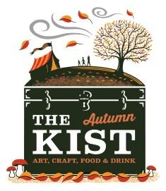
The Autumn Kist 2022
Exhibitor Information

Wigtown was announced as Scotland’s National Book Town in May 1997 with the first Book Festival taking place in 1999. The Festival, which is celebrating its 24th birthday, hosts over 200 events for adults, children and young people.
In 2019 audience numbers grew to 29,000 with unique visitors to the Festival being 13,500. Research shows that the event injected £4.3m into the local economy. The majority of events take place in and around the town with marquees erected as venues.
The Autumn Kist, now in its 13th year, will showcase the best of local, regional and national food and drink, crafts and visual art. The 9 x 18m marquee is situated in the road directly outside the County Buildings, Wigtown for the duration of the Festival, which runs from Friday 23rd September to Sunday 2nd October and is open to the public daily 10am-5pm (6.30pm at weekends). During this time, the road is closed to traffic and is for pedestrian access only.
Stallholder contracts will operate on a commercial basis, with Wigtown Festival Company meeting the costs of the marquee, hire of tables and advertising. A 160cm (l) x 80cm (w) table and seating will be provided for your use. Stallholders must provide all other equipment necessary for their stall and notify WFC if electricity is required for their stall.
Our aim is for a minimum of 20 stalls, showcasing a wide variety of products which will appeal to our audience.

Stall fees:
- £350 + VAT for the full 10 days
- £42.50 + VAT/day weekends
- £36 + VAT/day weekdays

We appreciate that you may like to take a stall for the duration of the Festival but may find it difficult to staff this at all times. We will do our best to arrange cover as necessary, by prior arrangement.
Application Process
Please complete and return the two-page application form (found below) along with a copy of your insurance certificate. If you are a food or drink producer, please also include a copy of your Food Hygiene Certificate and a copy of evidence that you are registered with your local Environmental Health Department. These can be submitted either by post or electronically by Friday 1st July 2022. Any applications received after this date will not be considered.

Please note: Priority will be given to those applying for the full 10 days, however in the past, due to high numbers of applications, in some cases we have only been able to offer exhibitors 5 days which included one of the weekends.

Each application will be carefully considered, and we will notify you by 5pm, Friday 8th July to let you know if you have been successful. If you are successful, we ask that you return your signed contract and a 25% deposit (of stall fees before VAT, which is non-refundable), along with 2 images of your products by 5pm, Friday 15th July. This will secure your stall space and will enable us to place an advert for The Autumn Kist including your business name in the Wigtown Book Festival Programme. The remainder of stall fees + VAT are due by 31st August.

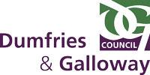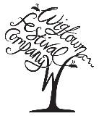

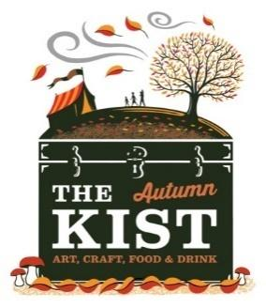
The Autumn Kist 2022
Exhibitor Application Form

Contact Name

Business Name

Address

Email Address

Telephone Number

Website/Facebook Page

Brief description of your products (if you have exhibited with us in the past, please include details of any new products introduced in the last 12 months)

If you do not have a Website or Facebook Account, please include two photographs of your products with your application.

Which days would you like to exhibit in The Autumn Kist?
(please highlight or underline your choice)
Full 10 days

Friday 23 September
Saturday 24 September
Sunday 25 September
Monday 26 September
Tuesday 27 October
Wednesday 28 October
Thursday 29 October
Friday 30 October
Saturday 1 October
Sunday 2 October

